Abdullah

Bscs 5

Task 1 :

Code :

@FunctionalInterface  
interface MessagePrinter {  
 void print();  
}  
public class Main {  
 public static void main(String[] args) {  
 MessagePrinter printer = () -> System.*out*.println("Welcome to Lambda Expressions!");  
 printer.print();  
 }  
}

Output :

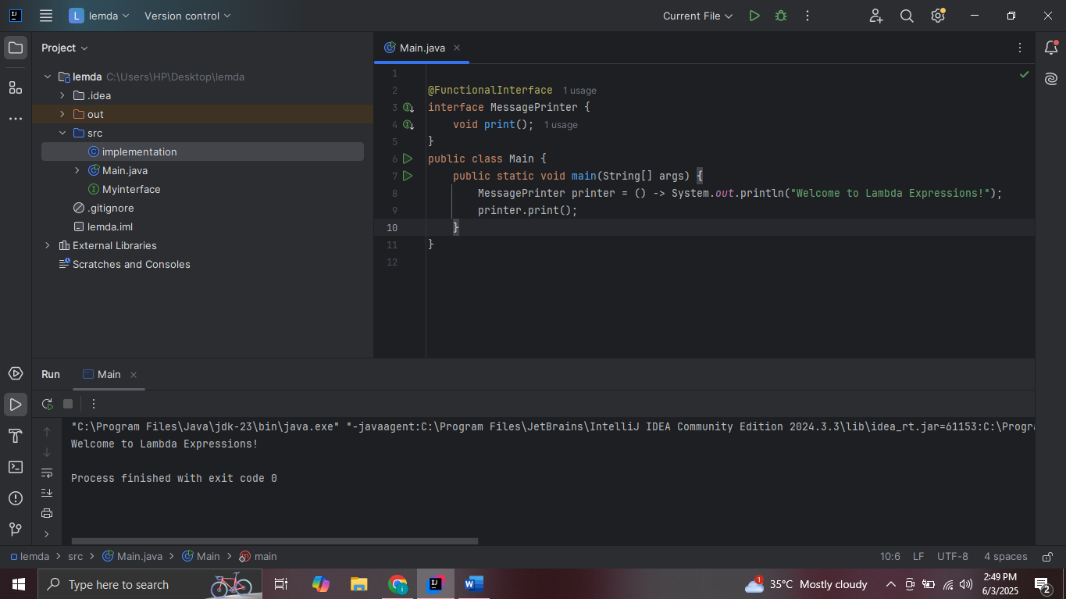

Task 2 :

@FunctionalInterface  
interface Greeter {  
 void greet(String name);  
}  
  
public class Main {  
 public static void main(String[] args) {  
 Greeter greeter = (name) -> System.*out*.println("Hello, " + name + "!");  
 greeter.greet("ibraheem"); // Output: Hello, Alice!  
 }  
}

Output :

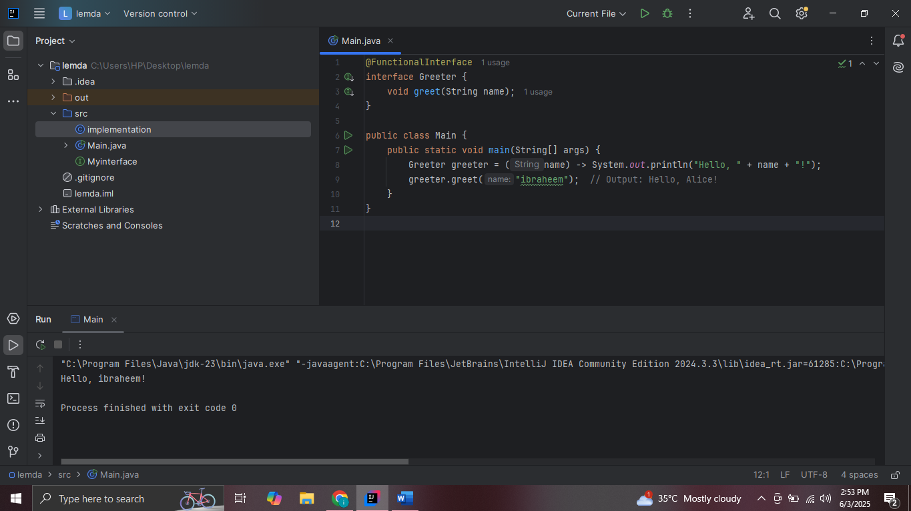

Task 3 :

@FunctionalInterface  
interface CheckEven {  
 boolean isEven(int n);  
}  
  
public class Main {  
 public static void main(String[] args) {  
 CheckEven check = (n) -> n % 2 == 0;  
  
 int number = 10;  
 boolean result = check.isEven(number);  
  
 System.*out*.println(number + " is even? " + result);  
 }  
}

Output :   
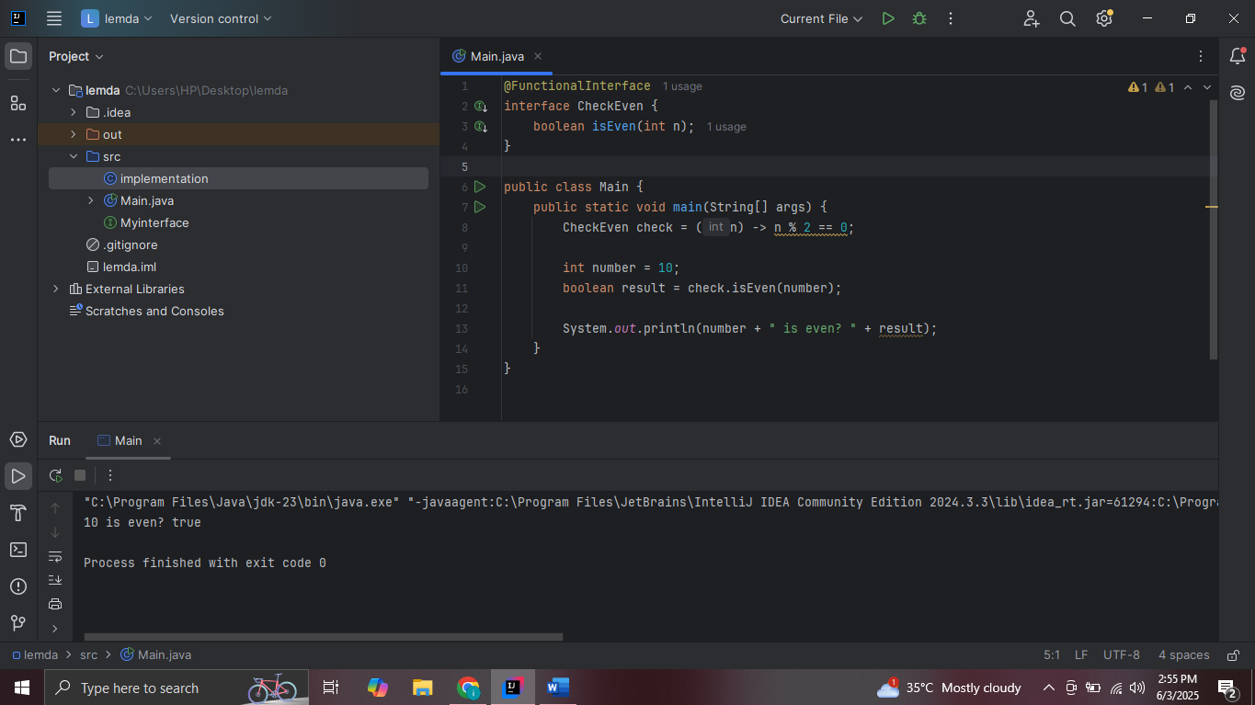

Task 4 :

@FunctionalInterface  
interface LengthFinder {  
 int getLength(String str);  
}  
@FunctionalInterface  
interface MathOperation {  
 int operate(int x);  
}  
public class Main {  
 public static void main(String[] args) {  
 LengthFinder finder = (str) -> str.length();  
 String text = "ibraheem";  
 int length = finder.getLength(text);  
 System.*out*.println("Length of \"" + text + "\" is: " + length);  
 MathOperation square = (x) -> x \* x;  
 int num = 5;  
 int result = square.operate(num);  
 System.*out*.println("Square of " + num + " is: " + result);  
 }  
}

Output :   
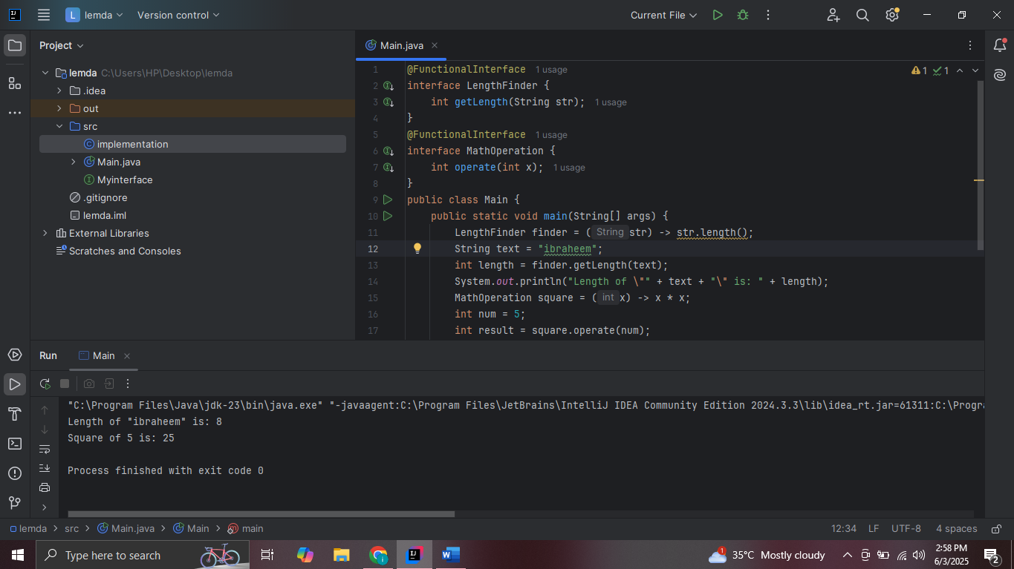

Task 5 :

@FunctionalInterface  
interface MathOperation {  
 int operate(int x);  
}  
public class Main {  
 public static void main(String[] args) {  
 int number = 5;  
 MathOperation square = (x) -> x \* x;  
 System.*out*.println("Square of " + number + " is: " + square.operate(number));  
 MathOperation cube = new MathOperation() {  
 @Override  
 public int operate(int x) {  
 return x \* x \* x;  
 }  
 };  
 System.*out*.println("Cube of " + number + " is: " + cube.operate(number));  
 }  
}

Output :   
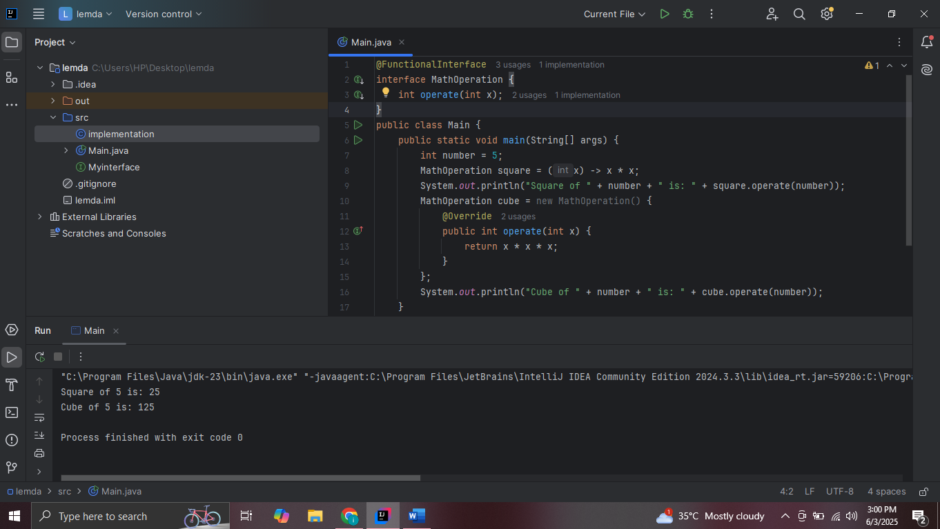

Task 6 :

@FunctionalInterface  
interface Adder {  
 int add(int a, int b);  
}  
@FunctionalInterface  
interface Multiplier {  
 int multiply(int a, int b);  
}  
@FunctionalInterface  
interface Displayer {  
 void show(String msg);  
}  
public class Main {  
 public static void main(String[] args) {  
 Adder adder = (a, b) -> a + b;  
 Multiplier multiplier = (a, b) -> a \* b;  
 Displayer displayer = (msg) -> System.*out*.println("Message: " + msg);  
 int x = 4, y = 5;  
 int sum = adder.add(x, y);  
 int product = multiplier.multiply(x, y);  
 System.*out*.println("Sum of " + x + " and " + y + " is: " + sum);  
 System.*out*.println("Product of " + x + " and " + y + " is: " + product);  
 displayer.show("Lambda expressions are powerful!");  
 }  
}

Output :

